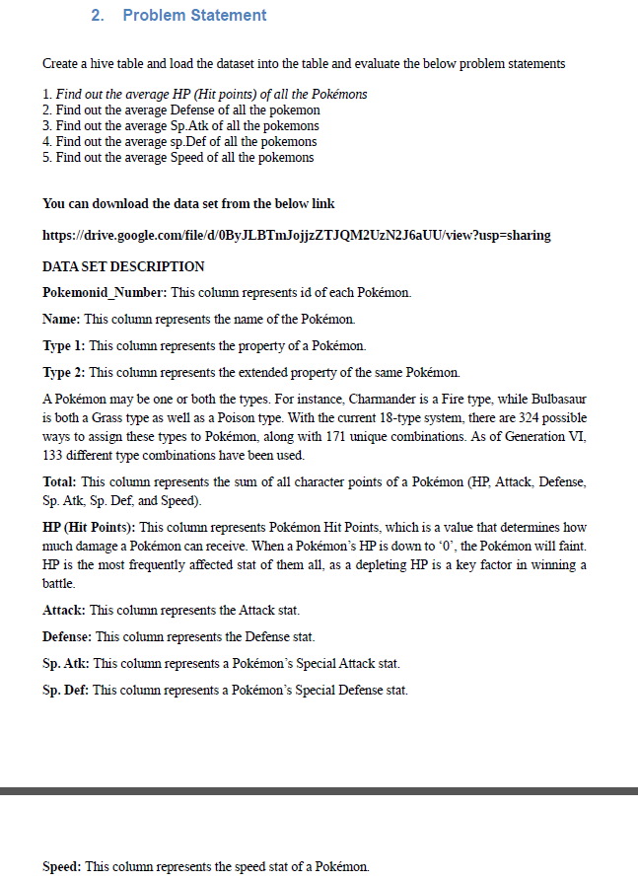

**First we will create table Pokémon using create command**

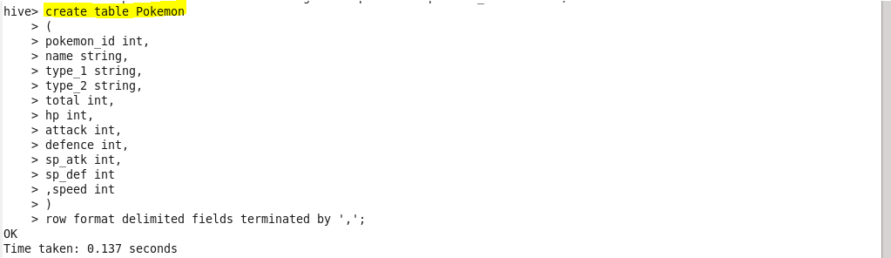

**Load pokemon.txt dataset to Pokémon table**

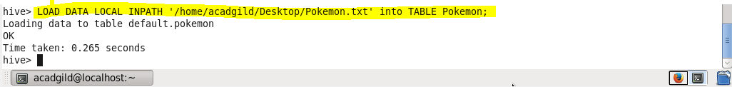

**Q.1. Find out the average HP (Hit points) of all the Pokémon’s**

Using select statement we will display the result

For finding out the average we will use avg function

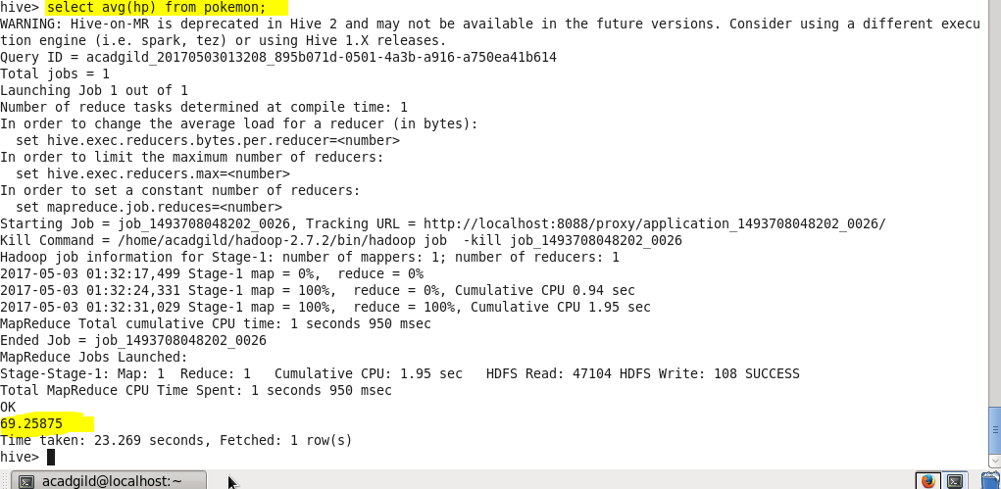

**Q.2. Find out the average Defense of all the Pokémon**

Using select statement we will display the result

For finding out the average we will use avg function

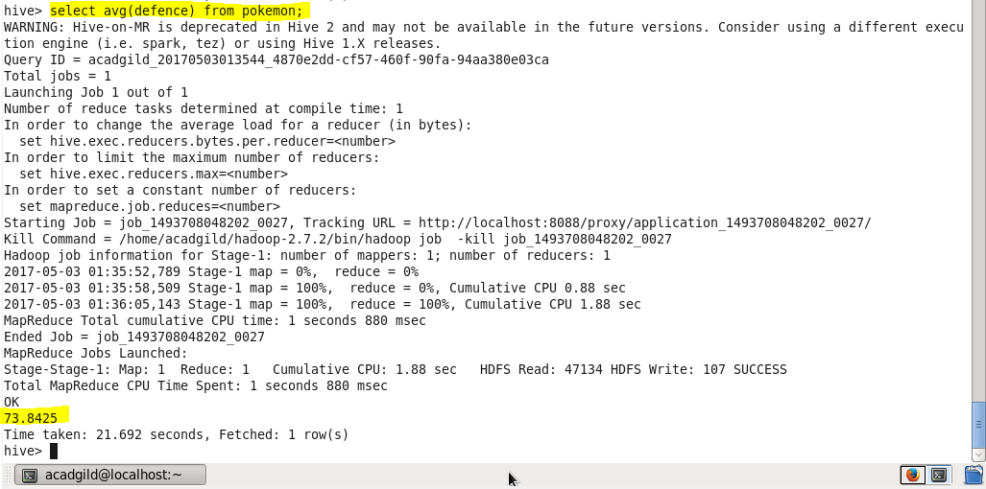

**Q.3. Find out the average Sp.Atk of all the Pokémon’s**

Using select statement we will display the result

For finding out the average we will use avg function

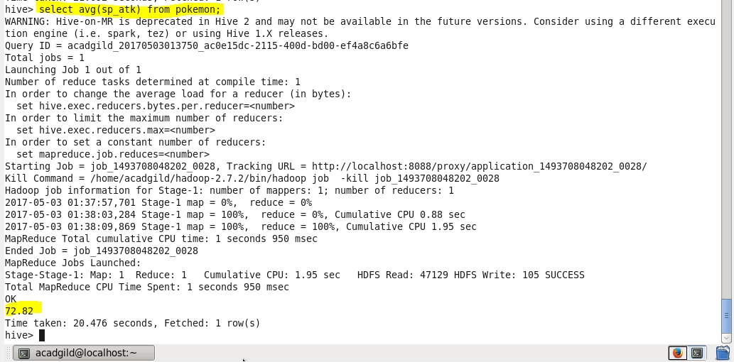

**Q.4. Find out the average sp.Def of all the Pokémon’s**

Using select statement we will display the result

For finding out the average we will use avg function

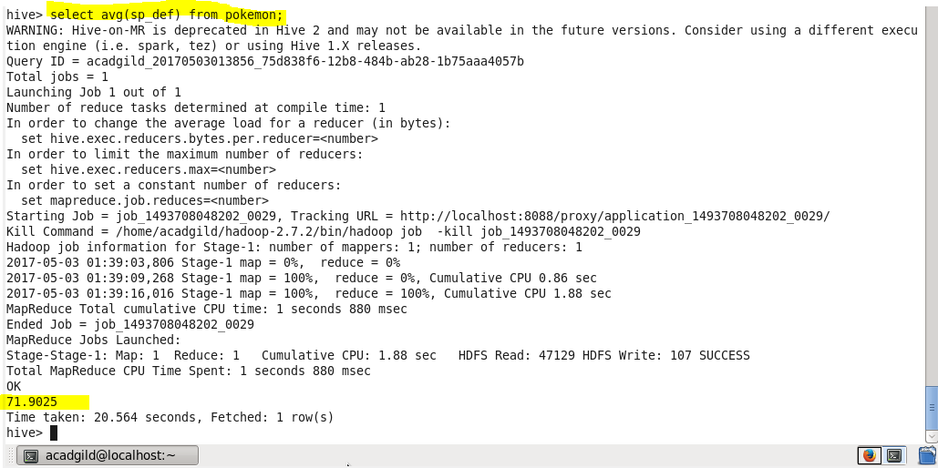

**Q.5. Find out the average Speed of all the Pokémon’s**

Using select statement we will display the result

For finding out the average we will use avg function

